American University of the Middle East
College of Engineering and Technology

CE/EE 270 - Introduction to Digital System Design
Spring 2026
Project Report
Project Deliverable 2
Digital Robotic Sensor on FPGA

Group Members
Name | Student ID | Major
AbdulRahman Ahmed | 10095516 | Electrical  Engineering
Yousef AlAbdulrazzaq | 75018 | Computer Engineering

Submitted on: 02 May 2026
Target Hardware: Altera Cyclone IV E DE2-115 FPGA
Toolchain: Quartus II 13.1 (64-bit) Web Edition

Table of Contents
1. Introduction 3
1.1. Problem Definition 3
1.2. Objectives 3
1.3. Structure of the Report 3
2. Contents and Findings 4
2.1. System Architecture and Block Diagram 4
2.2. Verilog HDL Implementation 5
2.3. Testbench and Simulation Results 8
2.4. Pin Assignments 10
2.5. Compilation and Hardware Deployment Note 11
3. Conclusion 13
3.1. Summary 13
3.2. Future Work 13
4. References 14
List of Figures
Fig. 1 System Architecture Block Diagram 4
Fig. 2 Robotic Sensor Processing Module Source 6
Fig. 3 Seven-Segment Decoder Module Source 7
Fig. 4 Top-Level Module Source 8
Fig. 5 Testbench Source Code 9
Fig. 6 Vector Waveform Simulation Results 9
Fig. 7 Quartus Pin Planner Assignments 11
Fig. 8 Successful Compilation Report 12
List of Tables
Table 1 Available Operations of the Robotic Sensor 4
Table 2 Seven-Segment Display Encoding (Active-LOW) 6
Table 3 Waveform Verification at Selected Time Intervals 10
Table 4 FPGA Pin Assignments (Cyclone IV E DE2-115) 10

1. Introduction

1.1. Problem Definition
Logic circuits form the foundation of every digital system, from simple controllers to complex processors. The aim of this project is to design and implement a Digital Robotic Sensor Processing system on an Altera Cyclone IV E FPGA using Verilog HDL within Quartus 13.1. The system models a simplified robotic platform whose behaviour is driven by combinational logic operating on two proximity sensors and a function selector.
The processing unit takes two 3-bit sensor inputs (G for the front-facing sensor and Y for the side-facing sensor), along with a 3-bit selector S that picks one of eight predefined operations such as motor-speed scaling, turning-angle adjustment, sensor comparison, and clearance evaluation. The result of the chosen operation is shown on a seven-segment display through a dedicated decoder module, while a separate overflow LED lights up whenever an arithmetic result goes beyond what a single hexadecimal digit can display.

1.2. Objectives
- Apply Karnaugh-map minimisation to derive simplified Boolean expressions for each of the eight operations performed by the robotic sensor.
- Translate the simplified logic into modular, synthesisable Verilog HDL across three independent design units.
- Develop a testbench that exercises every operation, including overflow corner cases, and verify correctness through vector waveform simulation.
- Map every input and output to physical FPGA pins on the Altera Cyclone IV E DE2-115 board through Quartus Pin Planner.
- Demonstrate that the integrated design compiles successfully and produces the expected results across all functional cases.

1.3. Structure of the Report
Section 2 presents the technical content of the project. It begins with the overall system architecture (Section 2.1) and the hierarchy of Verilog modules (Section 2.2), then walks through the testbench and simulation results (Section 2.3), the FPGA pin assignments (Section 2.4), and a closing note on compilation and hardware deployment (Section 2.5). Section 3 summarises the work and proposes future extensions, and Section 4 lists the references consulted.

2. Contents and Findings

2.1. System Architecture and Block Diagram
The design follows a clean two-stage hierarchy. A top-level module connects the external pins to two internal sub-modules. The first sub-module, robotic_sensor_proc, acts as the computational "brain." It receives the two sensor inputs and the selector, then produces a 4-bit display code D[3:0] and a 1-bit overflow flag OF. The second sub-module, seg7_decoder, converts the 4-bit code into the seven-bit active-LOW pattern that the on-board HEX0 display needs.
The interconnection follows the conceptual diagram in Figure 1. Sensor and selector signals enter at the left, the internal D[3:0] bus carries the result between modules, and the two outputs (the seven-segment display and the overflow LED) exit on the right. Note that the overflow signal does not pass through the decoder; it is routed directly from the processing module to the LED, ensuring that the overflow indication is independent of the displayed value.
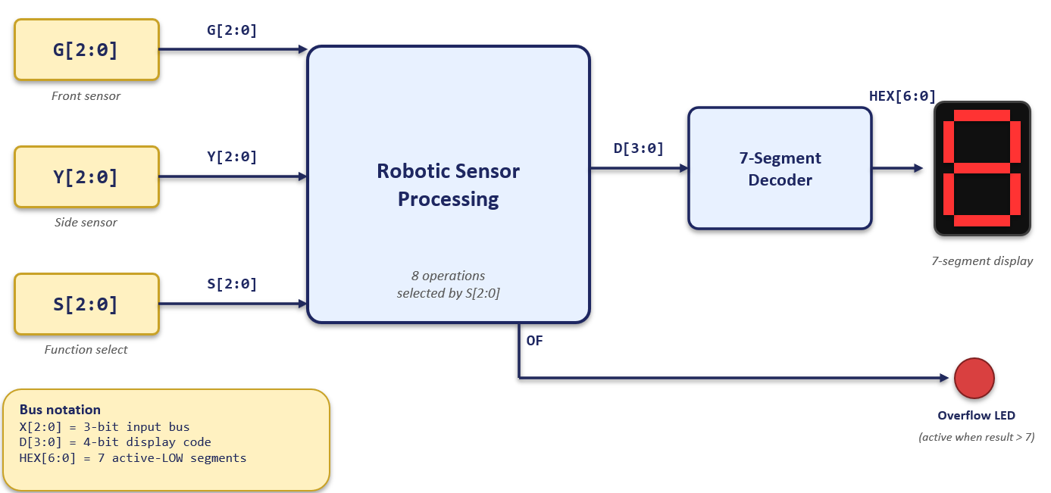
Figure 1: System Architecture Block Diagram
Table 1 lists the eight operations of the system and their interpretation in robotics terms.
S[2:0] | Function | Expression | Robotics Meaning
000 | Motor Speed Mapping | 2 × G | Scale the front-sensor reading to control motor speed.
001 | Turning Angle Mapping | 3 × Y | Scale the side-sensor reading to set the steering angle.
010 | Sensor Comparison | G == Y ? E : U | Show "E" if the robot is centred, "U" if it is drifting.
011 | Forward Adjustment | G + 3 | Simulate moving three units closer to a forward obstacle.
100 | Clearance Check | 7 − Y | Compute remaining lateral clearance before re-routing.
101 | Path Average | (G + Y) / 2 | Average the two readings to maintain alignment in narrow corridors.
110 | Difference | G − Y | Measure the disparity between front and side readings.
111 | System Off | blank | Stop the motors and blank the display.
Table 1: Available Operations of the Robotic Sensor

2.2. Verilog HDL Implementation
The design is split into three Verilog source files, each of which compiled successfully in Quartus 13.1. The processing module and the decoder are independent leaves of the design hierarchy, and the top-level module instantiates both while exposing only the external pins of the system.

2.2.1. Robotic Sensor Processing Module
The robotic_sensor_proc module receives G[2:0], Y[2:0], and S[2:0] and produces a 4-bit display code D[3:0] and a single overflow flag OF. To accommodate the arithmetic operations cleanly, the 3-bit inputs are zero-extended to 4-bit working values G4 and Y4. All eight intermediate results are computed in parallel as continuous wire assignments, and an always @(*) block with a case (S) statement performs the final 8-to-1 selection. Each branch also drives the overflow signal directly, so OF is computed alongside the result rather than as a post-stage flag.
We paid extra attention to the turning-angle operation, where 3 × Y can reach 21, which is far beyond what fits in 4 bits. Instead of using a multiplier, we implemented the value as a constant lookup over the three non-overflowing input cases (Y = 0, 1, 2), and let the overflow flag handle the rest of the domain. This keeps the synthesised circuit minimal and matches the K-map-driven approach we learned in class.
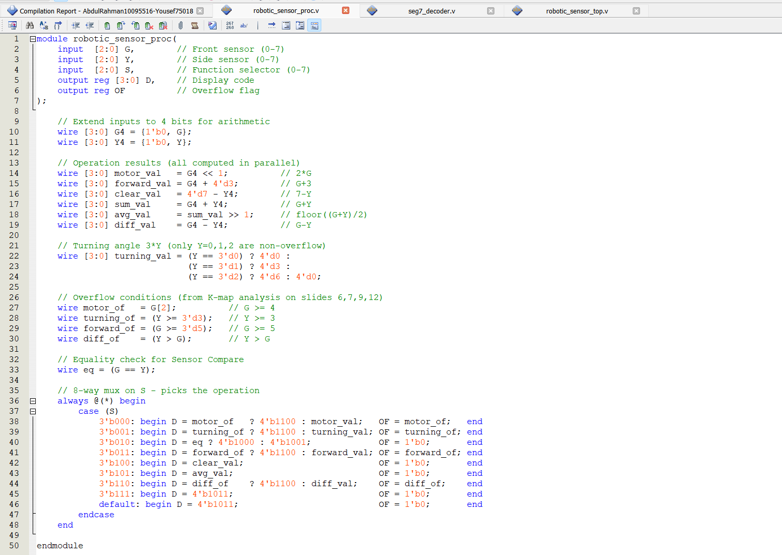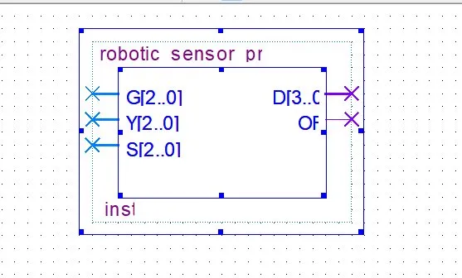
Figure 2: Robotic Sensor Processing Module (robotic_sensor_proc.v)

2.2.2. Seven-Segment Display Decoder
The seg7_decoder module receives the 4-bit display code D[3:0] and emits the 7-bit active-LOW segment pattern HEX[6:0], with bit ordering {g, f, e, d, c, b, a}. Active-LOW means a logical 0 turns a segment ON, which matches the wiring of the on-board HEX displays of the DE2-115.
Beyond the standard digits 0 through 7, the decoder defines four extra symbolic codes used by the processing module: 1000 shows the letter E for the equality result of the sensor comparison, 1001 shows the letter U for the not-equal result, 1011 blanks the display when the system is switched off, and 1100 lights segment g on its own, producing a horizontal bar that, together with the dedicated overflow LED, clearly flags an out-of-range arithmetic result. Any codes outside this set fall through to a safe blank pattern via the default branch.
Code D[3:0] | Symbol | HEX[6:0] (g…a) | Segments ON
0000 | 0 | 1000000 | a, b, c, d, e, f
0001 | 1 | 1111001 | b, c
0010 | 2 | 0100100 | a, b, d, e, g
0011 | 3 | 0110000 | a, b, c, d, g
0100 | 4 | 0011001 | b, c, f, g
0101 | 5 | 0010010 | a, c, d, f, g
0110 | 6 | 0000010 | a, c, d, e, f, g
0111 | 7 | 1111000 | a, b, c
1000 | E (equal) | 0000110 | a, d, e, f, g
1001 | U (not equal) | 1000001 | b, c, d, e, f
1011 | blank (off) | 1111111 | (none)
1100 | overflow bar | 0111111 | g
Table 2: Seven-Segment Display Encoding (Active-LOW)
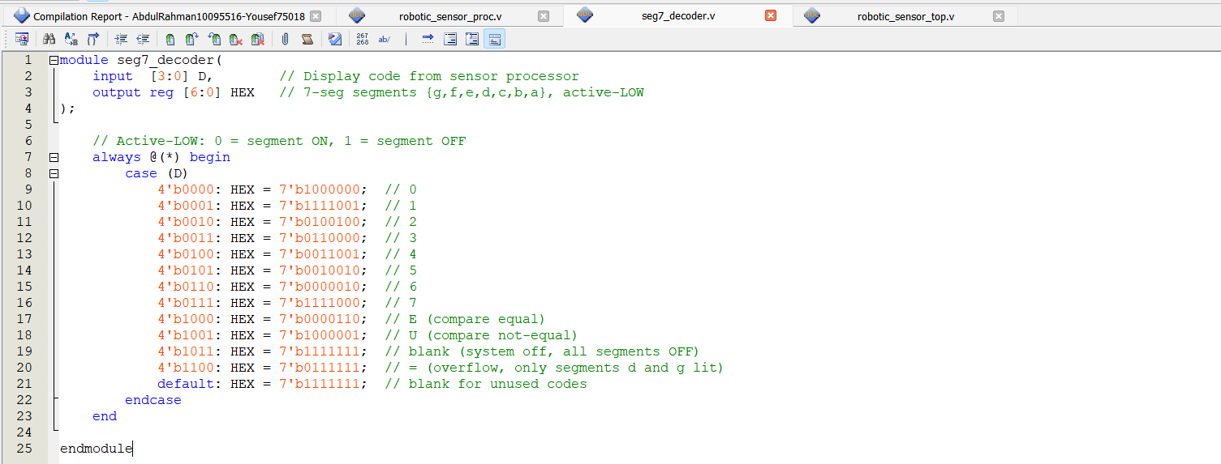
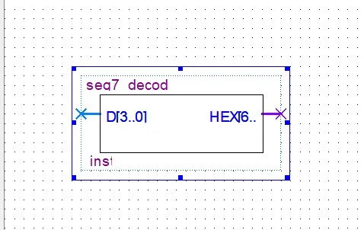
Figure 3: Seven-Segment Decoder Module (seg7_decoder.v)

2.2.3. Top-Level Module
The top-level module robotic_sensor_top exposes the five external buses and pins of the system and instantiates the two sub-modules. An internal 4-bit wire D carries the display code from the processing module to the decoder, while the overflow output is connected directly to the OF_LED output port. Only signals visible at the FPGA boundary are declared as ports of this module; everything else stays internal, which keeps the I/O footprint at exactly 17 pins.
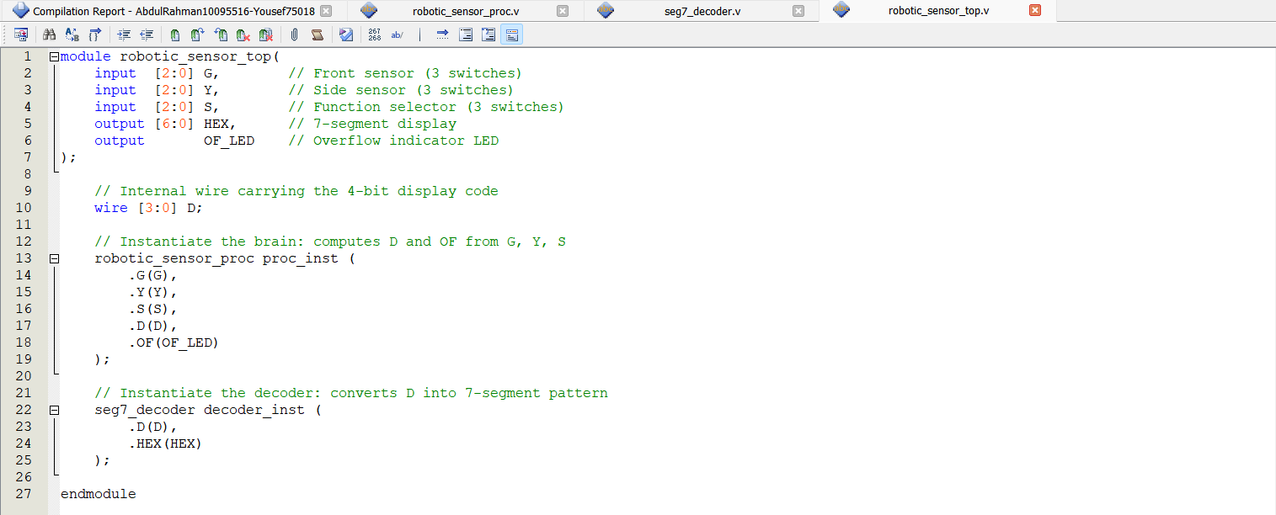
Figure 4: Top-Level Module (robotic_sensor_top.v)

2.3. Testbench and Simulation Results
A self-contained testbench, tb_robotic_sensor.v, was written to drive the processing module through every operation of the system. Each test vector applies a representative pair of (G, Y) values to the inputs, sets the appropriate S code, and waits 10 ns before advancing, which is long enough for the combinational logic to settle while keeping the overall simulation compact. Both nominal cases and overflow corner cases are tested for every selector value.
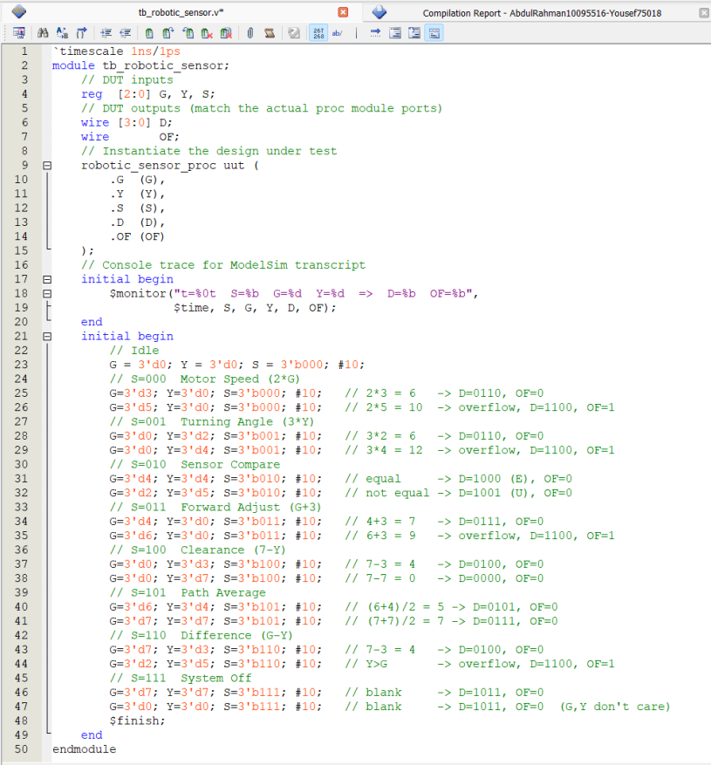
Figure 5: Testbench Source (tb_robotic_sensor.v)
We ran the simulation in the Quartus II Simulation Waveform Editor against the compiled netlist. The resulting vector waveform appears in Figure 6. From left to right the waveform sweeps through every selector value 000 through 111 and confirms that the displayed code matches the expected value for each input pair. The OF_LED trace pulses high exactly at the input combinations where overflow is mathematically expected, namely 2×5 = 10 (S=000), 3×4 = 12 (S=001), 6+3 = 9 (S=011), and 2−5 with Y > G (S=110), and stays low everywhere else.
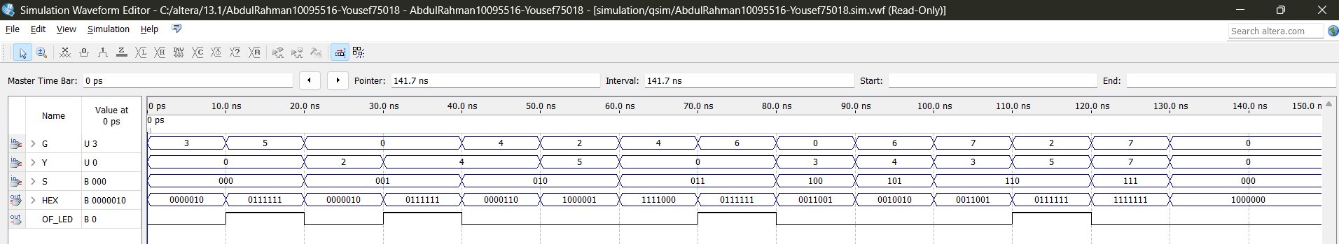
Figure 6: Vector Waveform Simulation Results (Full 160 ns Trace)
Table 3 walks through six representative time intervals from the waveform of Figure 6 and verifies, step by step, that the observed outputs match the expected outputs.
Time (ns) | G | Y | S | D[3:0] (sym) | OF | Verification
0–10 | 3 | 0 | 000 | 0110 (6) | 0 | Motor speed: 2×G = 2×3 = 6, displays "6".
10–20 | 5 | 0 | 000 | 1100 (bar) | 1 | 2×5 = 10 exceeds 9: overflow flag asserted, segment g lit.
20–30 | 0 | 2 | 001 | 0110 (6) | 0 | Turning angle: 3×Y = 3×2 = 6, displays "6".
40–50 | 4 | 4 | 010 | 1000 (E) | 0 | Sensor compare: G = Y, displays "E" (equal).
50–60 | 2 | 5 | 010 | 1001 (U) | 0 | Sensor compare: G ≠ Y, displays "U" (not equal).
90–100 | 6 | 4 | 101 | 0101 (5) | 0 | Path average: (6+4)/2 = 5, displays "5".
110–120 | 2 | 5 | 110 | 1100 (bar) | 1 | Difference: Y > G, overflow asserted, segment g lit.
120–130 | 7 | 7 | 111 | 1011 (blank) | 0 | System off: display blanked, OF low.
Table 3: Waveform Verification at Selected Time Intervals
Worked example. Consider the interval from 40 ns to 50 ns. The selector S = 010 enables the Sensor Comparison operation, and both inputs hold the same value: G = Y = 4. The equality check inside the processing module evaluates to true, so the case branch outputs D = 1000, the symbolic code for the letter E. The decoder maps 1000 to HEX = 0000110, which lights segments a, d, e, f, and g, exactly the pattern that draws the letter E on a seven-segment display. The overflow output stays low because the comparison operation cannot produce out-of-range arithmetic results. This matches the intended robotics interpretation: when both proximity sensors agree, the robot is centred and the display reads E.

2.4. Pin Assignments
We mapped the synthesised design to physical pins of the Altera Cyclone IV E EP4CE115F29C7 device, the chip used on the AUM lab DE2-115 development board. Inputs use slide switches SW[0..8], the seven-segment outputs drive the on-board HEX0 display, and the overflow flag is wired to the leftmost red LED, LEDR[0]. All pin numbers were taken from the Cyclone IV E pin reference shipped with the lab manual. Table 4 lists every assignment, and Figure 7 confirms them in Quartus Pin Planner.
Signal | FPGA Pin | Board Component | Functionality
G[0] | PIN_AB28 | SW[0] | Front sensor, bit 0 (LSB)
G[1] | PIN_AC28 | SW[1] | Front sensor, bit 1
G[2] | PIN_AC27 | SW[2] | Front sensor, bit 2 (MSB)
Y[0] | PIN_AD27 | SW[3] | Side sensor, bit 0 (LSB)
Y[1] | PIN_AB27 | SW[4] | Side sensor, bit 1
Y[2] | PIN_AC26 | SW[5] | Side sensor, bit 2 (MSB)
S[0] | PIN_AD26 | SW[6] | Function selector, bit 0 (LSB)
S[1] | PIN_AB26 | SW[7] | Function selector, bit 1
S[2] | PIN_AC25 | SW[8] | Function selector, bit 2 (MSB)
HEX[0] | PIN_G18 | HEX0 segment a | 7-segment a (active-LOW)
HEX[1] | PIN_F22 | HEX0 segment b | 7-segment b (active-LOW)
HEX[2] | PIN_E17 | HEX0 segment c | 7-segment c (active-LOW)
HEX[3] | PIN_L26 | HEX0 segment d | 7-segment d (active-LOW)
HEX[4] | PIN_L25 | HEX0 segment e | 7-segment e (active-LOW)
HEX[5] | PIN_J22 | HEX0 segment f | 7-segment f (active-LOW)
HEX[6] | PIN_H22 | HEX0 segment g | 7-segment g (active-LOW)
OF_LED | PIN_G19 | LEDR[0] | Overflow indicator (active-HIGH)
Table 4: FPGA Pin Assignments (Altera Cyclone IV E DE2-115)
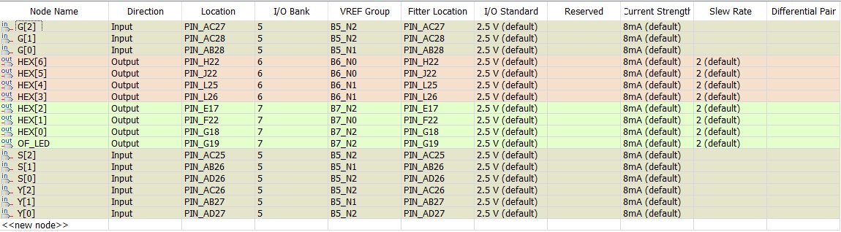
Figure 7: Quartus Pin Planner with Final Assignments

2.5. Compilation and Hardware Deployment Note
The complete design (three Verilog source files plus the testbench used for simulation) was synthesised by Quartus II 13.1 without any errors. The final compilation report is shown in Figure 8. The Total pins line reads 17 of 529 (3 %), which exactly matches the 17 pins listed in Table 4 and confirms that every signal in the design is bound to a physical FPGA pad. The fitter used only 50 of the 114 480 available logic elements (well below 1 %), which reflects how compact the K-map-minimised implementation is, and it used zero registers, which is correct since the entire design is purely combinational.
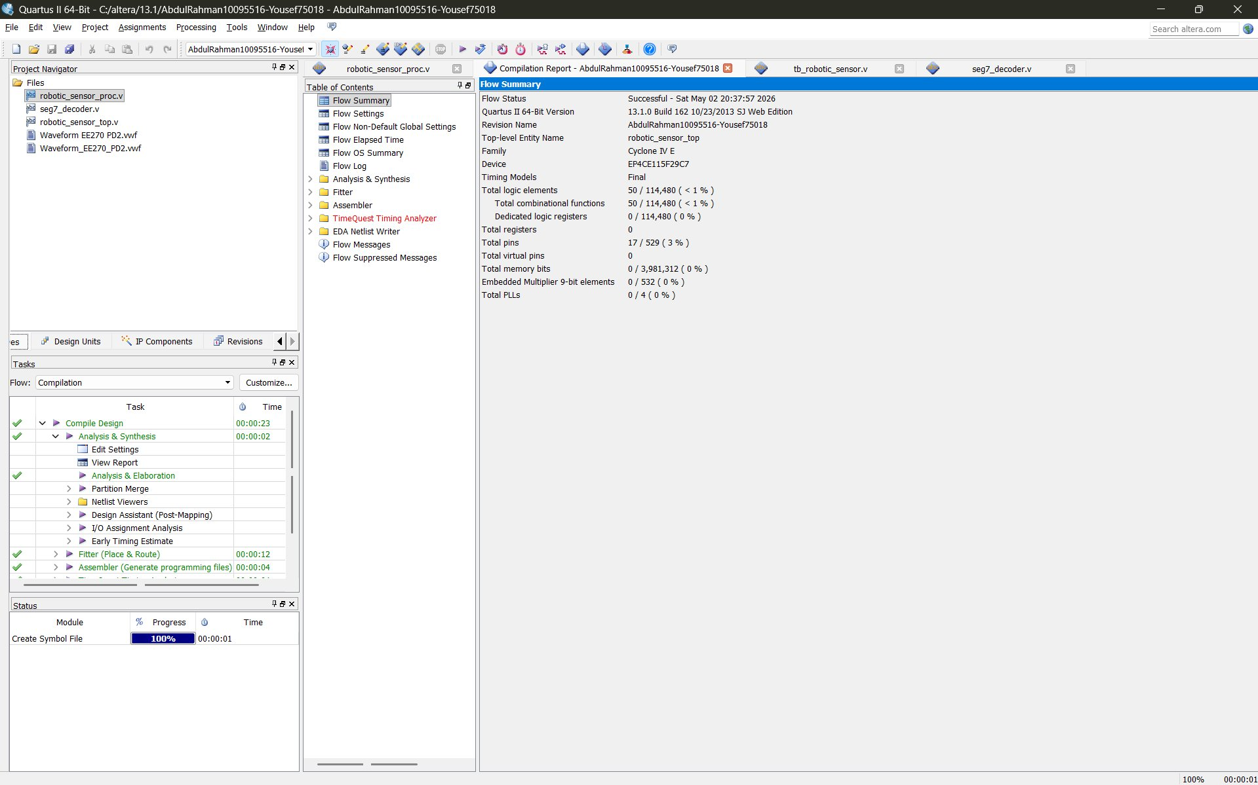
Figure 8: Successful Quartus Compilation Report
Note on hardware deployment. Because this project deliverable was submitted online, the team did not have physical access to a DE2-115 development board, so the final step of programming a real FPGA through the Quartus Programmer was not carried out. All other deliverables (design, synthesis, pin assignment, and functional verification through vector waveform simulation) are complete. Functional correctness was verified end-to-end against the compiled netlist rather than on actual silicon, but the design is ready to download as soon as physical hardware is available, and no further changes are needed.

3. Conclusion

3.1. Summary
This deliverable took the Project Deliverable 1 paper design and turned it into a fully synthesised, simulated digital system targeted at the Altera Cyclone IV E FPGA. We built eight selectable operations on two 3-bit sensor inputs through a hierarchical Verilog implementation made up of a processing module, a seven-segment decoder, and a top-level wrapper that wires the two together. K-map minimisation guided the choice of representations inside the processing module, and any arithmetic that went beyond the displayable range was cleanly handled by a dedicated overflow indication.
A self-checking testbench ran through every operation, including the overflow corner cases for the multiplications, the addition, and the difference. The resulting vector waveform matched the manually computed expected outputs at every transition, and the worked example shown in Section 2.3 confirmed that the seven-segment patterns also match the symbolic outputs called for by the project specification. After mapping all 17 signals to physical pins on the DE2-115 board, the project compiled cleanly with zero errors and is ready for hardware download as soon as a physical board is available.

3.2. Future Work
- Widen the sensor inputs from 3 bits to 4 bits so that two-digit decimal results are possible without triggering overflow on simple arithmetic.
- Add a synchronous clock and a small register file to support sequential operations such as moving averages over multiple readings.
- Drive a multi-digit seven-segment display so that overflow becomes a numerical value carried into the tens digit rather than a single-digit indicator.
- Replace the lookup-based 3 × Y operation with a generic constant multiplier and study the area-versus-latency trade-off.
- Integrate a soft microcontroller core (such as Nios II) to allow the operation selector to be driven by software rather than by physical switches, which would open the door to autonomous behaviour.

4. References
[1] M. M. Mano and M. D. Ciletti, Digital Design: With an Introduction to the Verilog HDL, VHDL, and SystemVerilog, 6th ed. Pearson, 2018.
[2] Intel Corporation (formerly Altera), Cyclone IV E Device Handbook. Available: https://www.intel.com/content/www/us/en/products/details/fpga/cyclone/iv.html
[3] Intel Corporation, Quartus Prime Standard Edition User Guide. Available: https://www.intel.com/content/www/us/en/docs/programmable/683373/current/overview.html
[4] Terasic Technologies, DE2-115 Development and Education Board User Manual. Available: https://www.terasic.com.tw
[5] CE/EE 270 Course Lab Manual, College of Engineering and Technology, American University of the Middle East, Spring 2026.
[6] CE/EE 270 Course Lecture Slides, Chapters 1 to 6 (Digital Systems and Binary Numbers; Boolean Algebra and Logic Gates; Gate-Level Minimization; Combinational Logic; Synchronous Sequential Logic; Registers and Counters), AUM, Spring 2026.

